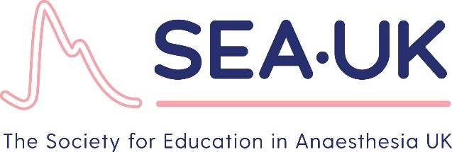

Society for Education in Anaesthesia (UK)

Registered Charity No. 1091996

Person Specification SEAUK Council Member (Medical)

Council membership is open to any practising Anaesthetist (Consultant/SAS) in the
United Kingdom. Council members should demonstrate active involvement in teaching and education and should be prepared to further develop such a role to support and inform the work of SEAUK.

Essential Criteria

- GMC registration.
- Active clinical practice in either Anaesthesia, Critical care or Pain Medicine.
- Member of SEAUK in good standing.
- Have a genuine enthusiasm for education and training.
- Practical experience in teaching and education.
- Have knowledge of the requirements for postgraduate training and revalidation.
- Able to attend the annual conference and the two annual Council meetings.
- Willing to become actively involved in training and education.
- Be prepared to contribute to the organisation and teaching in the SEAUK events.
- Willing to represent SEAUK at additional meetings like Specialist Society meeting at Association of Anaesthetists.
- Actively support the Society’s activities.

